

**UNITED INTERNATIONAL UNIVERSITY**

LAB REPORT- 02

Course Name: Control System Laboratory

Course Code: EEE 402/ EEE 4110 (A)

Submitted to;

RAHMAN, KALED MASUKUR

PROFESSOR

UIU

Submitted by;

Name: Monisha Roy

ID: 021-182-031

Name: Joyanta Debnath

ID: 021-182-032

Date of Submission: 10/06/2023

**EXP_02**: Modeling System by transfer function and state space.

**Objective:**

* To be able to determine the transfer function or state space representation of an unknown or partially known system.
* To be able to validate accuracy and predictive capability. This is done by comparing the model's output with the actual system response under different input conditions
* To be able to estimate the model parameters accurately based on experimental data.
* To be able to analyze the system's frequency response, determining the system's transient response characteristics (such as rise time, settling time, and overshoot), state space variables and equations.
* To be able to optimize the system's performance based on specific criteria.

**Part_B; Modeling of a cruise control system by transfer function:** The modeling of a cruise control system using transfer functions are mathematical representations that relate the output of a system to its input. In the context of a cruise control system, the transfer function describes the relationship between the desired speed set-point and the resulting vehicle speed.

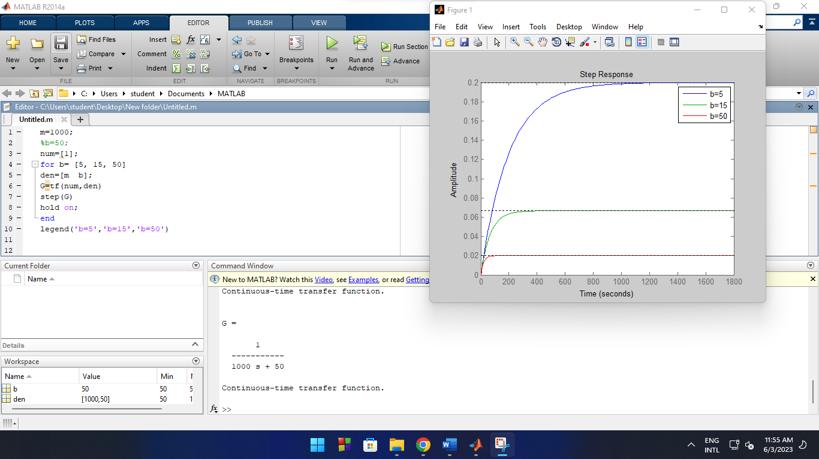**Task(i):** Using “for” loop to simulate the required system for different value of b =[5, 15, 50];

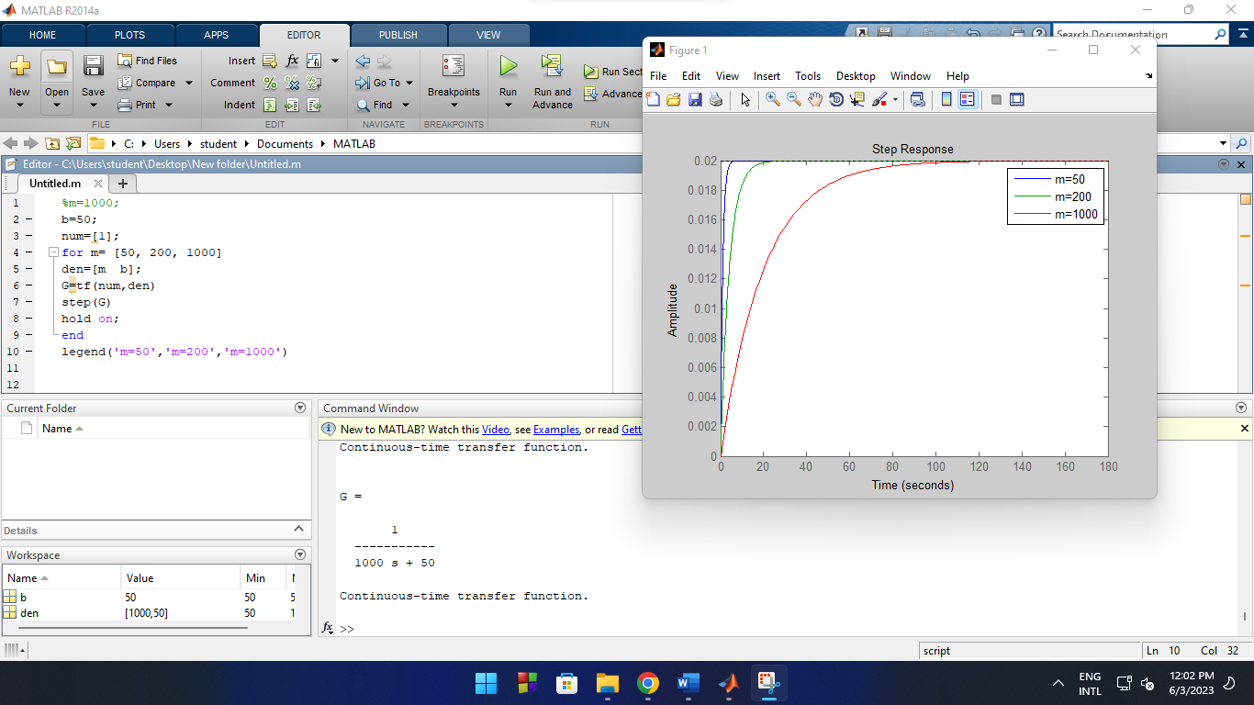**Task(ii):** Simulating the required system for different mass value of m =[50, 200, 1000];

**Task(iii):** Commenting on the changes in output in terms of steady state value and settling time;

Here, in terms of increasing the value of **b**, we can see (from the plot) a gradual decrease in steady state value as well as settling time. Meaning, there will be change in top speed and acceleration for different values of **b**.

Again, in terms of increasing the value of **m**, we can see (from the plot) a gradual increase in settling time while, steady state values are the same. Meaning, there will be same top speed but change in acceleration for different values of **m**.

**Discussion:** Using MATLAB for modeling a cruise control system using transfer functions enables us to understand and optimize the system's behavior, leading to improved control strategies and enhanced performance of the system.

**Part_C; Modeling of a DC motor by transfer function:** The modeling of a DC motor using transfer function is a mathematical representation that describes the relationship between the input and output of a system. In the case of a DC motor, the transfer function represents the relationship between the input voltages or currents and the resulting rotational speed or torque generated by the motor.

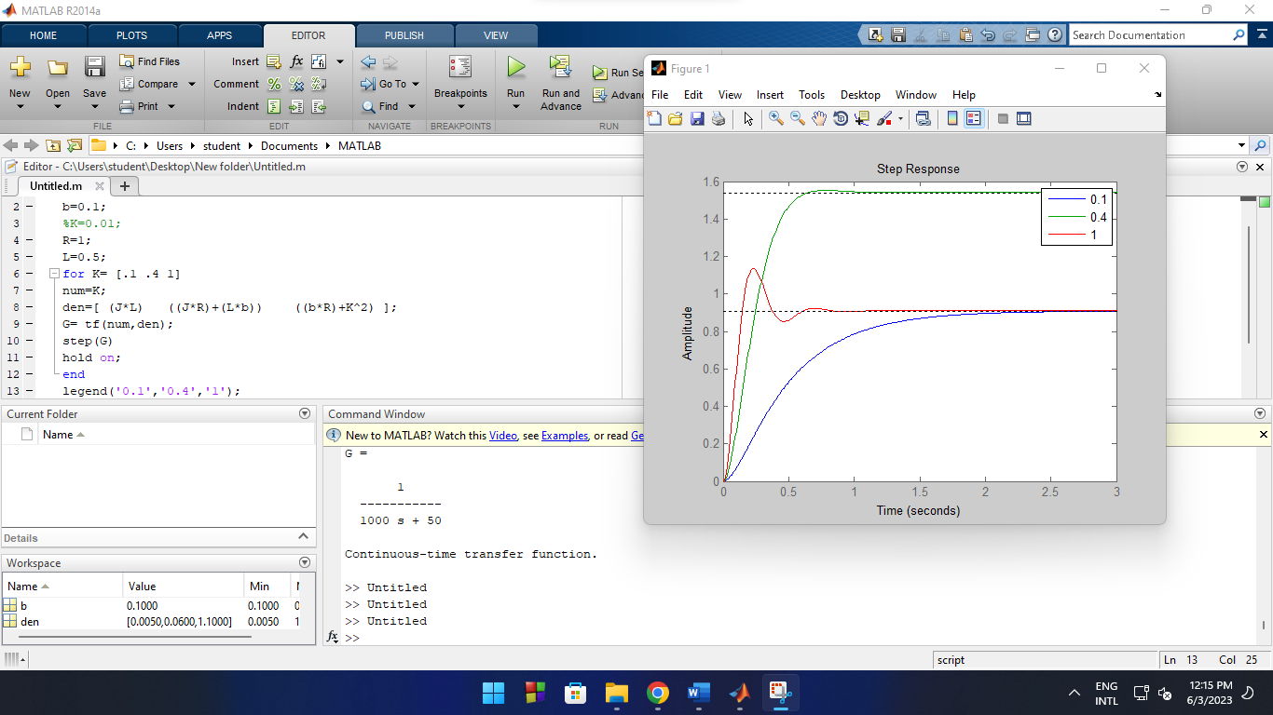**Task(i):** Simulate the required system for different value of J, b, R. Specially try K=[ .1 .4 1];

From transfer function,

(JR+bL)/JL= 2(T*Wn) …….(A) and, (Rb+k^2)/JL= Wn^2 …….(B)

From (A); T*Wn= constant (through varying k)

Here, T=1 (Critically damped); T>1 (Over damped); T<1 (Under damped) So, T= constant/Wn

**Task(ii):** Commenting on changes in output responses;

Here, for different values of **K**, we can see (from the plot) different curvatures.

At, K=0.1; we get over damped situation (where, T>1).

At, K=0.4; we get critically damped situation (where, T=1).

At, K=1; we get under damped situation (where, T<1).

**Discussion:** Using MATLAB for modeling a DC motor using transfer functions enables us to analyze system, control design, simulation and the system's performance in various applications.

**Part_E; Modeling a RLC circuit by state-space:** Modeling a RLC (resistor-inductor-capacitor) circuit using state-space representation commonly used approach in control systems analysis. In a RLC circuit, the elements interact to determine the circuit's response to an input voltage or current. The state-space representation captures this interaction by expressing the circuit's behavior as a set of first-order differential equations.

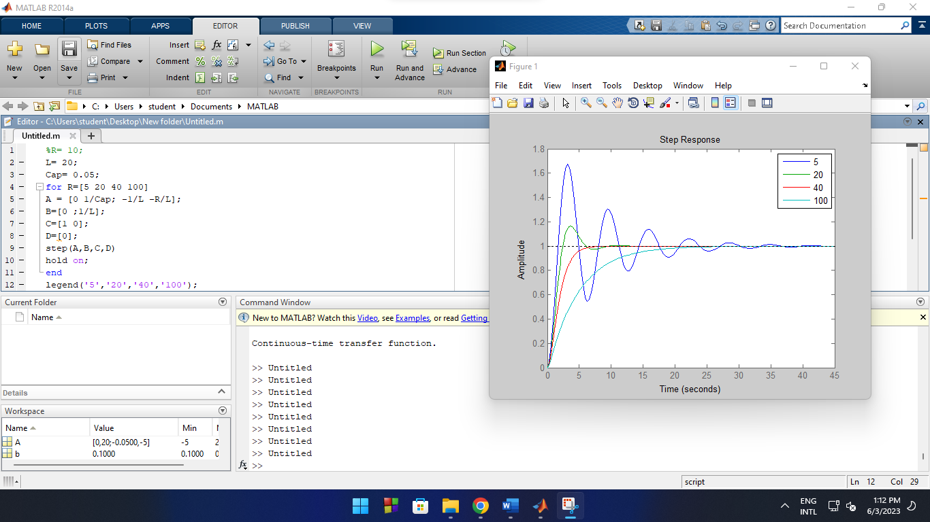**Task:** Simulating the required system for different values of R=[5 20 40 100].

Here, for different values of **R**, we can see (from the plot) different curvatures. Gradually increasing the value of **R**, we find different form of damping.

At, R= 5; we get un-damped situation.

At, R= 20; we get under damped situation.

At, R= 40; we get critically damped situation.

At, R= 100; we get over damped situation.

**Discussion:** Modeling a RLC circuit using state-space representation on MATLAB provides a comprehensive framework that enables us to analyze the circuit's dynamics, simulate responses, and optimize performance in various applications.

**Part_H; Simulating system response by SIMULINK:** In SIMULINK, we can construct a state-space model by assembling the individual components of the system using blocks and their interconnections. These components can represent the system's state variables, inputs, outputs, and matrices that define the system dynamics.

**Task:** 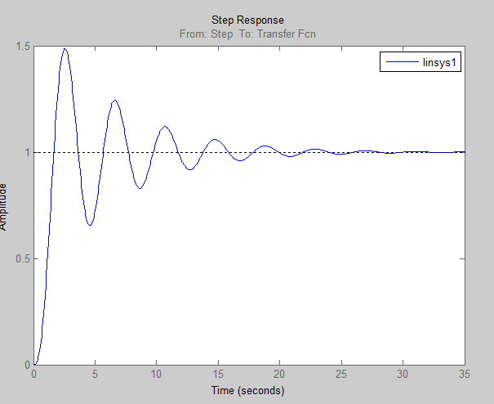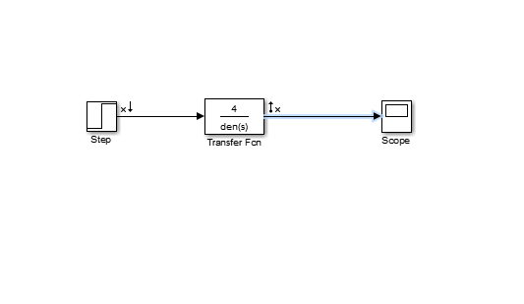

**Discussion:** By simulating state-space systems in SIMULINK, we can gain insights into their dynamic behavior, assess their performance, and validate their design before implementing them in real-world applications.

**Part_I; Home Work:**

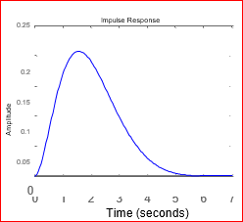**2.1| (a) CODE:**

A=[0 1 0; 0 0 1; -2 -4 -3]; B=[0;0;1];

C=[1 0 0];

D=[0];

impulse(A,B,C,D);

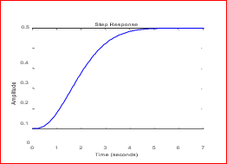**(b) CODE:**

A=[0 1 0; 0 0 1; -2 -4 -3]; B=[0;0;1];

C=[1 0 0];

D=[0];

step(A,B,C,D);

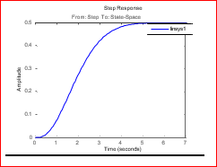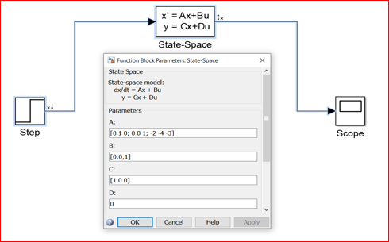**(c) SIMULINK: GRAPH:**

**(d) CODE: GRAPH:**

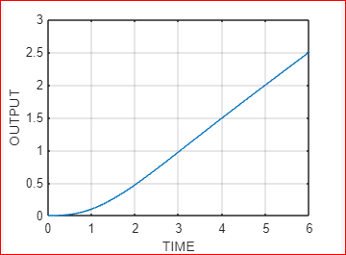A= [0 1 0;0 0 1;-2 -4 -3]; B= [0;0;1]; C= [1 0 0]; D= [0];

t= 6; u= 1+t;

y = lsim(A, B, C, D, u, t);

plot(t, y);

xlabel('Time');

ylabel('Output'); grid;

**2.2| CODE:**

State-space to transfer function;

A= [0 1 0;0 0 1;-2 -4 -3];

B= [0;0;1];

C= [1 0 0];

D= [0];

[n,d]= ss2tf(A,B,C,D);

G= tf(n,d);

Transfer Function to state-space (considering A1, B1, C1, D1);

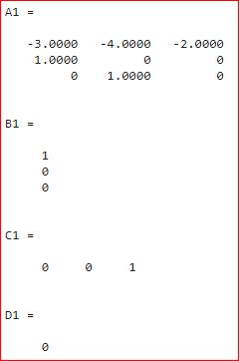[A1, B1, C1, D1]= tf2ss(n,d);

Here, we found difference between state-space variables (A,B,C,D) and (A1,B1,C1,D1). Because, there can be multiple state-space variables for a single transfer function. For multiple state-space variables, response will be same.

**Conclusion:** MATLAB's Control System Toolbox offers a wide range of functions and tools for simulating systems using transfer functions and state space representations. These techniques enable us to study and analyze system behavior, design control systems, and simulate system responses, facilitating the development of efficient control strategies.